DINEDASH Interview reports

Web Design

**AUTHOR: ERICK PASCAL**

# **INTRODUCTION**

In today’s fast-paced, digitally connected world, customer expectations in the restaurant industry are evolving rapidly. With rising demand for convenience, speed, and personalization, many customers are seeking smarter, tech-driven dining experiences. As part of the preliminary market research for the **DineDash Web App** — a digital platform designed to simplify restaurant experiences through **QR code scanning, real-time table availability, digital ordering, payment, and customer feedback collection**— field interviews were conducted to assess the practicality and desirability of such a solution among actual restaurant patrons and staff in Zimpeto, Maputo.

The research involved **on-site interviews** at popular dining spots such as **, FastFlavours, Belitos, and Dom Pastel Pizza**, engaging with a variety of stakeholders including **\*\*customers, waitstaff, chefs, and financial staf**f. Each interview was held in real-world conditions, allowing respondents to reflect on their dining routines, challenges they face in customer service or restaurant operations, and their openness to digital innovation in the food service industry. These interviews aimed to understand pain points like long wait times, lack of menu visibility, payment delays, feedback limitations, and inefficient table management — while also exploring their perception of QR-based, self-service systems.

The results provide insightful, practical evidence of user behavior and expectations. This introduction sets the stage for a deeper exploration of the data collected, offering a snapshot into how such a platform could reshape dining experiences in urban Mozambican eateries.

**User Interview Report**

**Interviewee Profile**

* **Name:** Sandra Macamo
* **Date:** 06 April 2025
* **Age:** 28
* **Occupation:** Auditor at EY
* **Device Used:** Android Phone
* **Location:** FastFlavours (Zimpeto)
* **Has Used Similar App Before?**  Yes

**Overview of Sandra’s Experience & Expectations**

Sandra is a frequent restaurant-goer, especially on weekends after work. She's used QR codes before but never in a full dining context like the one proposed. She shows interest in simplifying dining experiences, particularly to **save time**, **avoid awkward wait times**, and **stay informed during service**.

**Pain Points Identified**

|  |  |  |
| --- | --- | --- |
| Area | Pain Point | Suggested Feature/Improvement |
| Menu Access | Paper menus are often dirty or missing. Waiters take time to bring them. | QR code menus that load instantly and are easy to navigate. |
| Table Availability | She often walks into crowded restaurants and has to wait or leave. | Real-time table availability indicator before entry. |
| Ordering | Waiters take long, sometimes forget orders. | In-app ordering system that confirms order immediately. |
| Payment | She doesn’t always carry cash. Manual billing is slow. | Include **M-Pesa**, **mkesh**, and even offline payment confirmation. |
| Feedback | She rarely gives feedback because there’s no easy way. | Simple feedback system after payment with emojis or ratings. |

**Key Insights from Interview Questions**

**Menu and Table Experience**

* **Sandra says** QR menus are faster and more hygienic.
* **Pain Point:** She doesn’t like having to touch reused menus or ask multiple times for one.
* **Opportunity:** Highlight “clean, touch-free” access in the app’s value proposition.

**Autonomy & Trust**

* She is **comfortable with ordering and paying digitally**, provided the steps are simple.
* **Trust Factor:** She’s more willing if the app **confirms orders** and **shows a status bar** (e.g., "Order received", "Being prepared").

**Post-Meal Engagement**

* Sandra likes the idea of giving **short, instant feedback**, especially if she has a bad or very good experience.
* **Feature Request:** Allow optional “quick review” using smiley faces, stars, or a “What could be better?” box.

**Feature Priorities**

* Her top priority is **quick ordering**, followed by **table visibility**.
* She emphasized that the app **must be lightweight**, and **shouldn’t require installation**.

**Payment & Rewards**

* She prefers **M-Pesa**, and was excited about **loyalty rewards** for returning users.
* Suggested including: "Order 5 times, get 1 free" kind of model.

**Usability & Design**

* Sandra likes **big icons**, **pictures**, and **languages she understands** (suggests Portuguese).
* One of her fears is **pressing the wrong button** — she suggested having **clear labels** like “Place Order”, “Check Table”, “Call Waiter”.

**Summary of Key Suggestions from Sandra**

1. **Real-time Table Status:** Avoid awkward "do you have space?" moments.
2. **Simple Feedback Tool:** Just enough to share good or bad experiences.
3. **Fast-Loading Interface:** Must work even with slow connections.
4. **Multiple Payment Methods:** Especially local ones like M-Pesa.
5. **Multi-language Option:** English + Portuguese.
6. **Emergency/Assistance Button:** In case something goes wrong mid-order.
7. **Offline mode (optional):** For restaurants with weak Wi-Fi, show menu even without internet.

**Final Thoughts from Interviewee:**

“If this app helps me avoid waiting for a waiter and lets me pay faster, I would definitely choose restaurants that have it. Just make sure it's simple and doesn't confuse people. Not everyone is tech-savvy.”

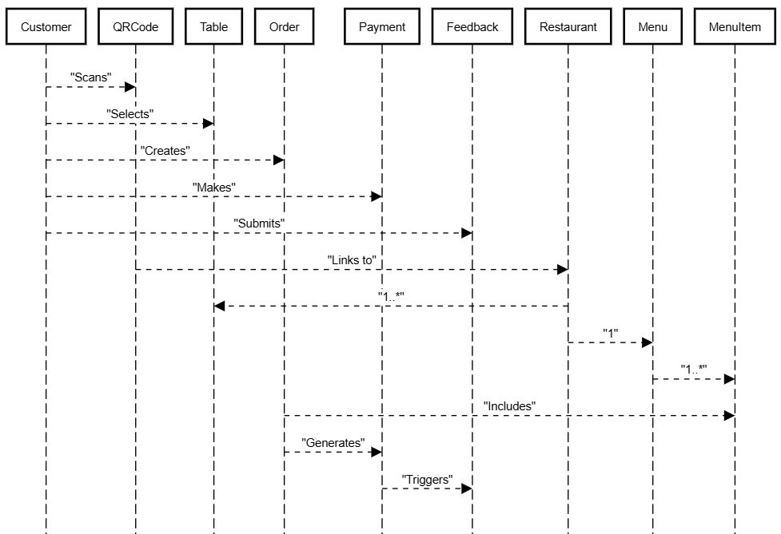

**User Interview Report – Field Interview at Fastflavours (Zimpeto)**

**Date:** 06 April 2025  
 **Location:** FastFlavours , Zimpeto  
 **Interviewer:** Erick Wasonga  
 **Interviewee Name:** Mornai   
 **Age:** 35  
 **Occupation:** Cambridge Educator  
 **Time of Interview:** 13h15 (after placing his order, while waiting)

**Interview Context:**

Mornai was seated at a 2-person table, waiting for his meal. He had been standing in line for a bit and mentioned the place is usually busy around lunchtime. I introduced myself as a student working on a restaurant tech project and asked if he had 5 minutes to help — he agreed.

**Summary of Interview Insights**

**Ordering Experience**

* **Pain Point:** “I had to wait 10 minutes to just get the menu and place my order.”
* **Quote:** *“The waiter was friendly, but they’re too few for so many customers.”*
* **Suggestion:** “If I could scan something and order right away, I’d prefer that — less waiting.”

**QR Code Awareness & Menu Preferences**

* **Used QR Menus Before?** ➡️ No
* **Reaction to QR Menu Idea:** *“So I just scan and see the food on my phone? That sounds fast. As long as I can see the pictures and prices clearly.*
* **Suggestion:** Add **pictures of food**, estimated preparation time, and maybe combos or daily specials.

**Table Availability**

* **Pain Point:** He mentioned he had to **walk around to check which table was free**.
* **Suggestion:** *“Even just something simple, like colors showing which table is free or reserved would help.*

**Payment**

* **Preferred Payment:** M-Pesa
* **Trust in Digital Payments?** “Yes, but I need to get a confirmation instantly. I hate when I pay and the waiter says they didn’t see it.

**Feedback & Follow-Up**

* Mornai says he never gives feedback because there’s no platform for it.
* Would leave feedback if it was **quick and part of the checkout process**.
* Suggested idea: “If I give a good review, maybe next time I get a discount?”

**Key Suggestions from João (Summarized)**

|  |  |  |
| --- | --- | --- |
| Challenge | Mornai's Feedback | Feature Opportunity |
| Slow ordering | Wants to skip waiting for the waiter | Scan-to-order immediately |
| Confused about free tables | Hates walking around to check availability | Visual table status display |
| No menu while waiting | Wants to browse while seated | QR code menu with images |
| Payment delay issues | Wants instant M-Pesa confirmation | Payment + receipt shown in app |
| No review system | Wants simple feedback option | In-app review with rewards |

**Final Words from Mornai:**

“If a restaurant had this, I’d come back more often. I just want it to work fast and not confuse me. Keep it simple.”

**Business Owner Interview Report – *Titos Lualange, FastFlavours, Zimpeto***

**Date:** 06 April 2025  
**Time:** 13h45  
**Interviewer:** Erick Wasonga  
**Interviewee:** Titos Lualange  
**Restaurant Name:** FastFlavours  
**Type:** Mid-size, affordable Mozambican food  
**Location:** Zimpeto (near Shoprite)  
**Interview Setting:** In-person at the restaurant, quiet hour

**Interview Goal**

To present the idea of a **QR-based web app** for FastFlavours, and gather feedback on how it could:

* **Improve customer experience**
* **Reduce wait times**
* **Streamline table management**
* **Enable digital billing and tipping**
* **Collect real-time feedback**

**Key Points from the Interview**

**1. Understanding of the App Idea**

“You mean, the customer scans and sees the menu on their phone — then orders from there?”

*Titos quickly understood the idea.*

He was interested especially in:

* **Customers placing orders without waiting for a waiter**
* **Automatic ticket sent to the kitchen**
* **Digital receipt sent by SMS or WhatsApp**

**2. Main Business Pain Points**

|  |  |  |
| --- | --- | --- |
| Area | Current Challenge | App Solution |
| Table Management | Waiters often forget who’s seated where. People leave if they don’t find seats quickly. | **Table selection screen** with visual layout & live status |
| Ordering | Orders written by hand; customers complain of delays and mistakes | **Direct ordering from customer’s phone** = faster & more accurate |
| Menu Changes | Menu updates require reprinting | **Dynamic digital menu** that owner/staff can update anytime |
| Feedback | Customers rarely give useful feedback; no system to track service ratings | **In-app feedback form with tip or rating** after payment |
| Payments | M-Pesa is slow; staff forget to give receipts; cash payments can go untracked | **QR-based billing system** with automatic digital receipts and **tip button** |

**3. Titos' Thoughts on the QR Feature**

“QR codes are easy — everyone scans for M-Pesa already. If it can show them the table layout, menu, and a way to pay… that’s big.”

**He emphasized:**

* It must be **simple to understand** for low-tech customers.
* Needs support for **M-Pesa**, **cash**, and possibly **mobile cards** later.
* Wants a “**Waiter Mode**” where staff can also use the system to help older clients.

**4. Concerns & Suggestions**

|  |  |  |
| --- | --- | --- |
| **Concern** | **Detail** | **Potential Solution** |
| Training | “My staff won’t get it fast.” | Add a **1-minute video tutorial**, create an **admin guide** |
| Wi-Fi or Internet | Some customers might not have data | Option to use **restaurant’s local Wi-Fi**, or offer a **mini offline mode** for staff use |
| Setup Time | “I don’t want to spend a week installing things.” | Make it a **web-based app**, no installations — just a printed QR and owner login |

**Final Comments from Titos:**

“If it makes my life easier and customers don’t complain anymore — I’m in. But start with just a few tables and show me how it works first.”

**Summary & Action Points**

**Titos is highly interested** in testing a system that:

* Uses QR codes for **menu access, table selection, ordering, tipping, and billing**
* Helps reduce manual errors and staff stress
* Improves speed during peak hours
* Gives customers more control and shorter wait time

**He suggests:**

* Starting with a **trial of 3–5 tables**
* Allowing both **customer-side** and **waiter-side** access
* Keeping the interface clean, colorful, and usable in both **Portuguese and English**

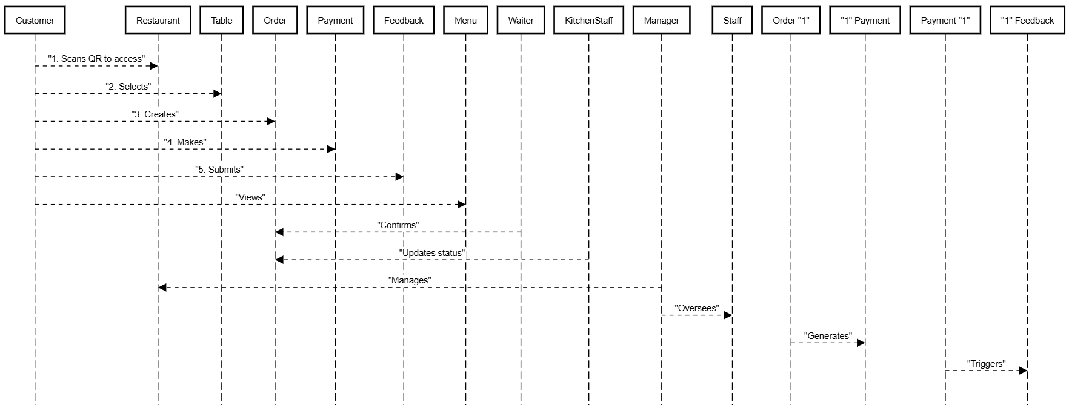

**User Interview Report – Field Interview at Misau Rock (Zimpeto)**

**Date:** 07 April 2025  
 **Location:** Legends Restaurant, Zimpeto  
 **Interviewer:** Erick Wasonga  
 **Interviewee Name:** *Manuel Guilherme* **Age:** 40  
 **Occupation:** Restaurant Manager  
 **Time of Interview:** 17h45 (during end-of-day wind-down)

**Interview Context:**

I caught up with Manuel at the end of a busy lunch-to-dinner transition. He’s been managing Misau Rock for over 5 years and was open to giving insight into how the current system works — and where technology could help.

**Summary of Interview Insights**

**Current Workflow & Pain Points**

* **Operational Challenge:** *“Our biggest issue is delay between seating, ordering, and delivery during rush hour.”*
* **Quote:** *“Waiters get overwhelmed quickly. We lose sales just because people don’t want to wait.”*
* **System Used:** Pen and paper ordering, manual checks for available tables.

**Views on QR Code System**

* **Experience with QR Menus:** *“We tested a basic QR menu once, but people didn’t understand it well. Still, with good design, I believe it can work.”*
* **Biggest Concern:** Internet reliability and ensuring customers **feel guided** through the digital process.
* **What He’d Love:**
  + Real-time table occupancy map
  + App that **sends order directly to the kitchen**
  + Dashboard to monitor activity

**Management & Financial Angle**

* **Quote:** *“If this system can track orders, cut paper use, and reduce billing errors — that’s a win.”*
* **Wishlist:**
  + Daily report summaries (orders, feedback, payments)
  + Integration with POS
  + Auto-generated receipts linked to M-Pesa/Visa

**Key Suggestions from Manuel (Summarized)**

|  |  |  |
| --- | --- | --- |
| Challenge | Manuel's Feedback | Feature Opportunity |
| Customer drop-off | Orders take too long during peak hours | Scan > Order > Send to kitchen directly |
| Manual work overload | Staff can’t keep up | Smart system to assist staff |
| No real-time table status | Difficult to know where to sit | Live table map in app |
| Billing issues | Errors in manual receipts | Digital receipt + payment confirmation |
| Poor feedback tracking | Feedback gets lost or not written down | Quick digital review option |

**Final Words from Manuel:**

“Technology is welcome if it helps — but it must be simple. If it helps both staff and customer, we’re willing to try.”

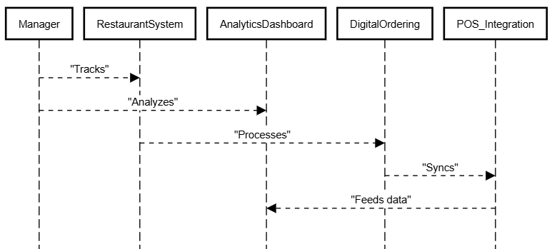

**User Interview Report – Field Interview at Dom Pastel, Pizza (Zimpeto)**

**Date:** 07 April 2025  
 **Location:** Dom Pastel Pizza, Zimpeto  
 **Interviewer:** Erick Wasonga  
 **Interviewee Name:** Chef Armando   
 **Age:** 42  
 **Occupation:** Head Chef at Domm Pizza  
 **Time of Interview:** 17h10 (after lunch rush, during prep for evening orders)  
 **Device Used:** Samsung Galaxy Tab (kitchen system)

**Interview Context:**

Chef Armando was in the prep area reviewing orders. I introduced myself as a university student working on a tech-based ordering solution for restaurants and asked if I could ask a few questions. He was open to sharing insights during his short break.

**Summary of Interview Insights – Kitchen/Chef Perspective**

**Ordering Process**

* **Pain Point:** “Sometimes, waiters confuse table numbers or forget to mark when a customer modifies a pizza.”
* **Quote:** *“It’s hard to stay efficient when you’re guessing what the customer really wanted.”*
* **Suggestion:** He’d love a **clear, digital list of orders** that come **directly from the customer** — no handwriting or missed details.

**Digital System Feedback**

* **Used QR Code System Before?** ➡️ Yes – in a Maputo hotel kitchen.
* **Reaction to QR Code Orders:** *“It’s much better. The kitchen gets clean instructions, even with special notes like ‘no cheese’ or ‘extra onions.’”*
* Also said a screen in the kitchen displaying **live orders** would be ideal.

**Timing and Efficiency**

* “We lose time when orders are delayed between the table and kitchen.”
* Suggested the system should **sync instantly** once the order is placed.
* *“It’s not just about speed. Accuracy saves ingredients too.”*

**Waste & Cost Control**

* Mentioned that **incorrect orders** waste ingredients, especially premium toppings like bacon and olives.
* *“If a digital order helps reduce waste, it also helps the restaurant save money.”*

**Key Suggestions from Chef Armando**

|  |  |  |
| --- | --- | --- |
| Challenge | Chef’s Insight | Suggested Feature |
| Confused/missed orders | Wants orders directly from customers | QR scan-to-order, auto sync to kitchen |
| Wasted ingredients | Wrong orders = thrown food | Improve order accuracy through app |
| Time lost between waiter & kitchen | Wants real-time order visibility | Kitchen screen + alerts |
| Customization | Needs clear customer notes | Allow customers to tick/choose custom toppings |

**Final Words from Chef Armando:**

“If your app can send clear, real-time orders to the kitchen without mistakes, I support it 100%. It makes my job easier, and the customer gets exactly what they wanted.”

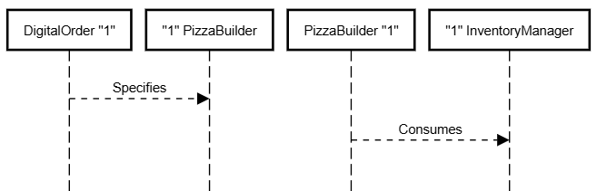

**User Interview Report – Field Interview at Dom Pastel Pizza (Zimpeto)**

**Date:** 07 April 2025  
 **Location:** Dom Pastel Pizza, Zimpeto  
 **Interviewer:** Erick Wasonga  
 **Interviewee Name:** *Paulo Machava* **Age:** 42  
 **Occupation:** Civil Engineer (visiting from Matola)  
 **Time of Interview:** 18h45 (family dinner time, seated with wife and two kids)

**Device Used:** iPhone 11

**Interview Context:**

Paulo had just placed a family order and was helping his kids find a game on his phone. I approached and introduced myself. He was a bit reserved at first but agreed after I explained the study was about improving restaurant service using tech.

**Summary of Interview Insights**

**Ordering with Family**

* **Pain Point:** *“With kids, you need things fast. Waiting 15 minutes for a waiter with a menu is tough.”*
* **Comfort with Tech:**
  + Uses QR codes at work sites and at some cafés.
  + Open to trying tech-based ordering **if it’s simple and shows combos or kid-friendly items**
* **Quote:** *“I don’t want to ask a waiter ten questions about what pizza is in stock. Just show me on my phone.”*

**Feature Preferences**

* Wants a visual menu with **pictures**, portion sizes, and combo deals.
* Sees value in **real-time table availability** when arriving with a group.
* Interested in **saving previous orders** to repeat his kids’ favorites.

**Payment & Trust**

* **Preferred Payment Method:**
  + Usually pays by **Visa or M-Kesh**.
  + Less comfortable with “scan and pay” unless there's **clear confirmation**.
* **Quote:** *“If I get a clear ‘Paid Successfully’ message, then I’m good. But don’t make me guess.”*

**Ideas and Suggestions**

* Add a **“Family Combo” section** to app menus.
* Offer **split payment option** (for friends or coworkers sharing a bill).
* Include **allergen info** and **spice levels** — helpful for kids.

**Key Suggestions from Paulo (Summarized)**

|  |  |  |
| --- | --- | --- |
| Challenge | Paulo’s Feedback | Feature Opportunity |
| Long wait with family | Wants fast, clear ordering | Tap-to-order from seat |
| Confusion about availability | Doesn’t want to ask staff repeatedly | Real-time item & table availability |
| Payment confidence | Needs assurance after digital payments | Instant receipt + app confirmation |
| Kids have favorites | Wants to reorder easily | "Favorite orders" shortcut |

**Final Words from Paulo:**

“The idea is good — especially for families. Just don’t overcomplicate it. Let me see, choose, pay, and enjoy.”

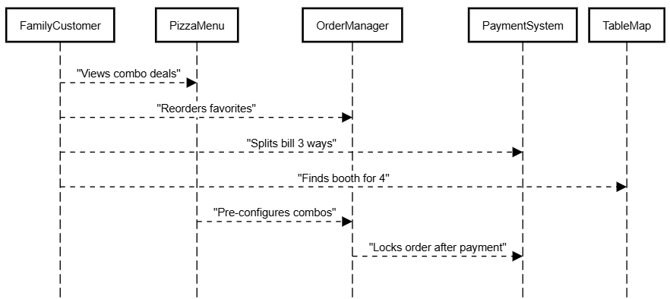

**User Interview Report**

**Date:** 07 April 2025  
 **Location:** Dom Pastel, Zimpeto  
 **Interviewer:** Erick Wasonga  
 **Interviewee Name:** *Elias Tomas* **Age:** 23  
 **Occupation:** Computer Science Student at Universidade Joachim Chissano  
 **Time of Interview:** 14h30 (during a solo lunch break)

**Device Used:** Samsung Galaxy A52

**Interview Context:**

Elias had just finished placing his order and was scrolling on his phone. I introduced myself and asked if he had a few minutes to help with research on restaurant technology — he smiled and said, *“Sure, I’m a CS student too — I love this stuff!”*

**Summary of Interview Insights**

**Tech Comfort & Ordering Habits**

* **QR Code Usage:** *“Yeah, I’ve used QR menus at Pizza Hut and at a café in Maputo.”*
  + Likes how **fast and private** it feels.
  + Prefers **not** having to wait for someone to bring the menu.
* **Ordering Preference:** *“If I can just scan, tap and confirm my order — that’s ideal. I only need human help if there's an issue.”*
* **Biggest Frustration:** *“When QR menus are just PDF links... no interaction, no photos, no prices... it’s like using a textbook.”*

**Feature Interest**

* **Would Use a Table Map?** Yes — *“Makes it easier if I’m coming with friends.”*
* **Would Leave Feedback?** *“Yeah, especially if I get points or something in return.”*

**Payment Preferences**

* **Preferred Method:**
  + M-Pesa
  + Visa (linked to student account)
* **Quote:** *“But M-Pesa must give me instant feedback. I don’t want to sit there wondering if it went through.”*

**Wishlist Features**

* Live order tracker (even if it’s just “Order received” > “Cooking” > “Ready”)
* Estimated wait time
* Option to save previous orders for faster re-ordering
* Push notification when food is ready (or a buzzer system through the app)

**Key Suggestions from Elias (Summarized)**

|  |  |  |
| --- | --- | --- |
| Challenge | Elias’ Feedback | Feature Opportunity |
| PDF-only QR menus | Wants interactive menus with images & prices | Fully responsive web menu with UI |
| Delay in food delivery | Wants real-time order status | Order progress tracking system |
| Feedback is boring | Wants rewards for leaving reviews | Points, discounts, or badges |
| Repeat orders | Wants quick repeat from history | Save & reorder function |

**Final Words from Elias:**

“I’d love to see more Mozambican restaurants using tech this way — it saves time and feels modern. But it has to be clean, fast, and localized.”

**User Interview Report – Field Research at Belitos Restaurant (Zimpeto)**

**Date:** 07 April 2025  
 **Location:** Belitos Restaurant, Zimpeto  
 **Interviewer:** Erick Wasonga

**Interviewee : Customer – Joaquim Silva**

**Age:** 42  
 **Occupation:** Business Owner (Electronics Shop)  
 **Time:** 14h00  
 **Device Used:** Samsung Galaxy S22

**Ordering Experience:**

* Feels QR codes speed up the process, but scanning is occasionally frustrating in low light.
* Quote: *“If it worked perfectly every time, I wouldn’t even touch a paper menu again.”*

**Suggestions:**

* Clear categories, daily specials section, and ability to search items.
* QR code backup as a short URL.
* Real-time table map for faster seating.

**Payment & Feedback:**

* Needs instant receipts.
* Willing to leave reviews if prompted post-payment.
* Suggested loyalty points or small discounts for regular feedback.

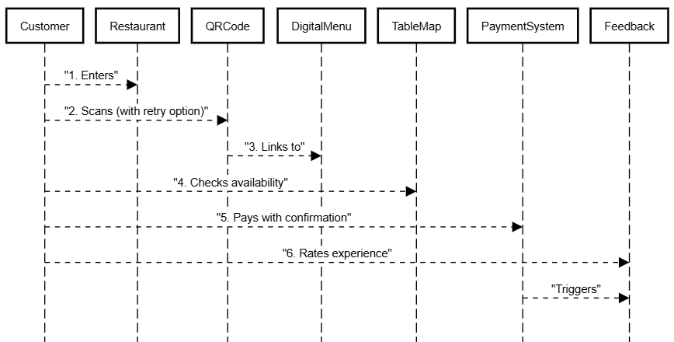

**Interviewee : Waiter – Rosa Manuel**

**Age:** 26  
 **Experience:** 3 Years at Belitos  
 **Time:** 13h30 (During mid-rush cleanup)

**Experience with Customers:**

* “During busy times, I have to run from one table to another. Some people get annoyed just waiting for the menu.”
* Knows about QR codes but says many older customers don’t use them.
* Quote: *“If customers could place orders themselves, I’d have more time to focus on service.”*

**Pain Points:**

* Orders written manually, sometimes get misread or lost during rush.
* Customers often ask for items that are out of stock, which wastes time explaining.

**Suggestions:**

* Menu should show **available** items only.
* Include food preparation time so customers don’t pressure the kitchen.
* Suggests a “call waiter” button in the app: *“Sometimes people wave but we’re too busy to notice.”*

**Tech Familiarity:**

* Uses WhatsApp and M-Pesa daily. Comfortable learning new tools if trained.
* Would like staff access to see orders in real-time: “If I could see what’s coming from the kitchen digitally, that would save back-and-forth trips.”

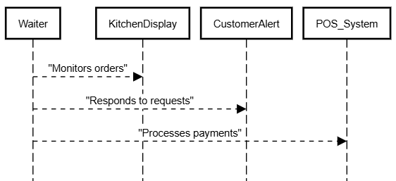

**Interviewee 3: Accountant – Celina Moiane**

**Age:** 33  
 **Position:** Restaurant Accountant (Handles daily revenue tracking, reconciliations)  
 **Time:** 15h00 (Post-lunch lull)

**Financial View:**

* "We lose a lot of time reconciling cash and M-Pesa each night."
* Sometimes waiters forget to mark paid orders properly, causing confusion in records.
* Quote: *“Errors don’t just affect money — they create doubt between staff and management.”*

**Suggestions:**

* Digital receipts for every order that link directly to sales logs.
* Daily summaries that separate payment methods (Cash / M-Pesa / Card).
* QR code orders would help eliminate unclear handwriting and pricing errors.
* Wants **dashboards** that help track busiest hours and top-selling items.

**Collaboration with Other Staff:**

* Emphasized need for tech to **help staff**, not replace them.
* Would support training sessions if new tech is introduced.
* Encourages incentives: “If a waiter uses the app correctly all week, maybe a bonus or reward?”

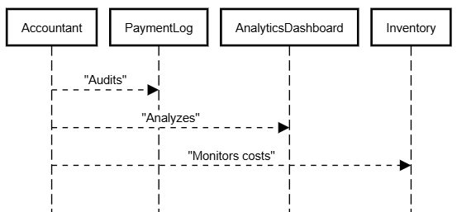

**Key Suggestions – All Interviews Combined**

|  |  |  |
| --- | --- | --- |
| Role | Challenge | Suggested Solution |
| Customer (Joaquim) | Poor QR code scanning and slow seating | Larger QR codes, backup URLs, real-time table availability |
| Waiter (Rosa) | Overwhelmed during rush, order mistakes | Self-ordering via QR, live kitchen sync, stock display |
| Accountant (Celina) | Manual reconciliation, human error | Digital receipts, payment tracking, sales analytics dashboard |
| All | Communication gaps | Integrate notifications for order status, staff alerts, and customer feedback |

**Final Thoughts**

* **Joaquim (Customer):** *“Make it smoother and I’ll always use it.”*
* **Rosa (Waiter):** *“Let customers order directly — I’ll focus on giving great service.”*
* **Celina (Accountant):** *“Digital systems help us grow, but they must be clear, accountable, and reliable.”*

**User Interview Report – Field Interview at Belitos Restaurant (Zimpeto)**

**Date:** 07April 2025  
 **Location:** Belitos Restaurant, Zimpeto  
 **Interviewer:** Erick Wasonga  
 **Interviewee Name:** Maria Fernandes  
 **Age:** 29  
 **Occupation:** Teacher  
 **Time of Interview:** 12h30 (while enjoying a dessert)  
 **Device Used:** iPhone 13 Pro Max

**Interview Context:**

Maria was sitting at a quiet table by the window, savoring a dessert after her main course. She mentioned she visits Belitos occasionally for a break from her busy schedule. She was receptive to answering some questions and offering suggestions for improving her dining experience.

**Summary of Interview Insights**

**Ordering Experience**

* **Pain Point:** “I had to wait for the waiter to bring the menu and then had to wait for quite a while before my order was taken. It’s just frustrating when I want to decide quickly.”
* **Quote:** *“Sometimes it feels like you’re forgotten in the rush. I’d prefer to handle things myself, like looking at the menu when I’m ready.”*
* **Suggestion:** “Having the option to scan a QR code and browse the menu right away would be ideal. It would save me a lot of time and make the process smoother.”

**QR Code Awareness & Menu Preferences**

* **Used QR Menus Before?** ➡️ Yes
* **Reaction to QR Menu Idea:** *“I’ve used QR codes in a few places before, and I liked the idea. The only thing is, I need to be able to zoom in on the food pictures. Sometimes they’re too small to see properly.”*
* **Suggestion:** *“For me, the bigger the pictures of the food, the better. Also, it would be helpful to include information about the dish, like its ingredients or whether it’s spicy.”*

**Table Availability**

* **Pain Point:** Maria mentioned she’s had to wander around a few times looking for a seat, which isn’t ideal when the restaurant is full.
* **Suggestion:** *“It would be helpful if the app displayed whether tables are available or not before we walk in. I think a quick check on my phone would save a lot of hassle.”*

**Payment**

* **Preferred Payment:** M-Pesa or Credit Card
* **Trust in Digital Payments?** “I’m comfortable with digital payments, but sometimes the confirmation doesn’t come through immediately, and I wonder if it worked.”
* **Suggestion:** *“I’d feel more confident if the app provided a clear payment confirmation message right after the transaction, showing that the payment went through.”*

**Feedback & Follow-Up**

* Maria said she usually doesn't leave feedback unless it’s encouraged or part of the experience.
* However, if feedback was easy and quick, she’d be more likely to share her thoughts.
* Suggested idea: *“Maybe after I’ve paid, the app can pop up with a quick rating system. A discount or a free drink on my next visit would motivate me to do it.”*

**Key Suggestions from Maria (Summarized)**

|  |  |  |
| --- | --- | --- |
| Challenge | Maria's Feedback | Feature Opportunity |
| Waiting for the menu | Frustrated by waiting for the menu and server | Instant access to menu via QR scan |
| Small menu pictures | Needs bigger, clearer images of dishes | Large food pictures with zoom-in option |
| Table availability | Has to search for available tables when busy | Visual indicator for available tables |
| Delayed payment confirmation | Needs quicker confirmation for digital payments | Instant confirmation of payment in app |
| No feedback system | Would leave feedback if it was easy and offered incentives | Quick feedback system with rewards or discounts |

**Final Words from Maria:**

*“I would definitely use an app like this. I don’t mind using my phone for convenience, as long as it makes the experience smoother. I like the idea of being able to see tables, order without waiting, and get rewards for feedback.”*

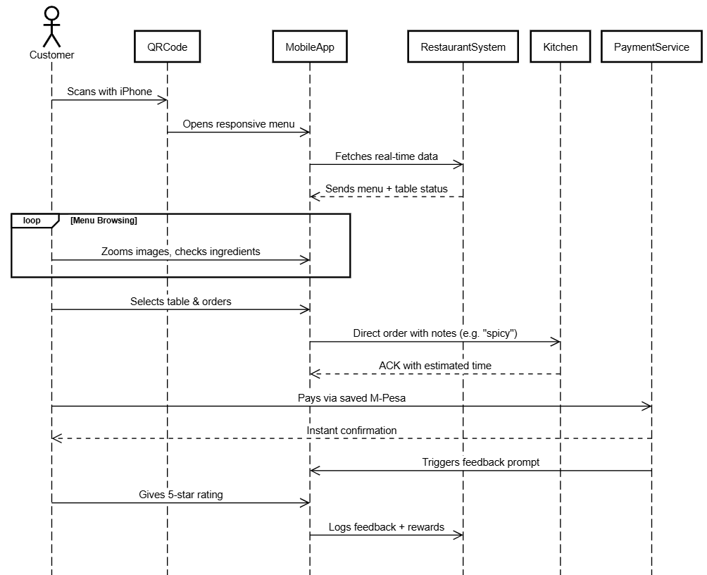

**User Interview Report – Field Interview at Misau Rock (Zimpeto)**

**Date:** 07 April 2025  
 **Location:** Misau Rock Restaurant, Zimpeto  
 **Interviewer:** Erick Wasonga  
 **Interviewee Name:** João Pedro   
 **Age:** 35  
 **Occupation:**   
 **Time of Interview:** 13h15 (after placing his order, while waiting)

**Interview Context:**

João was seated at a 2-person table, waiting for his meal. He had been standing in line for a bit and mentioned the place is usually busy around lunchtime. I introduced myself as a student working on a restaurant tech project and asked if he had 5 minutes to help — he agreed.

**Summary of Interview Insights**

**Ordering Experience**

* **Pain Point:** “I had to wait 10 minutes to just get the menu and place my order.”
* **Quote:** *“The waiter was friendly, but they’re too few for so many customers.”*
* **Suggestion:** “If I could scan something and order right away, I’d prefer that — less waiting.”

**QR Code Awareness & Menu Preferences**

* **Used QR Menus Before?** ➡️ No
* **Reaction to QR Menu Idea:** *“So I just scan and see the food on my phone? That sounds fast. As long as I can see the pictures and prices clearly.”*
* **Suggestion:** Add **pictures of food**, estimated preparation time, and maybe combos or daily specials.

**Table Availability**

* **Pain Point:** He mentioned he had to **walk around to check which table was free**.
* **Suggestion:** *“Even just something simple, like colors showing which table is free or reserved would help.”*

**Payment**

* **Preferred Payment:** M-Pesa
* **Trust in Digital Payments?** “Yes, but I need to get a confirmation instantly. I hate when I pay and the waiter says they didn’t see it.”

**Feedback & Follow-Up**

* João says he never gives feedback because there’s no platform for it.
* Would leave feedback if it was **quick and part of the checkout process**.
* Suggested idea: “If I give a good review, maybe next time I get a discount?”

**Key Suggestions from João (Summarized)**

|  |  |  |
| --- | --- | --- |
| Challenge | João's Feedback | Feature Opportunity |
| Slow ordering | Wants to skip waiting for the waiter | Scan-to-order immediately |
| Confused about free tables | Hates walking around to check availability | Visual table status display |
| No menu while waiting | Wants to browse while seated | QR code menu with images |
| Payment delay issues | Wants instant M-Pesa confirmation | Payment + receipt shown in app |
| No review system | Wants simple feedback option | In-app review with rewards |

**Final Words from João:**

“If a restaurant had this, I’d come back more often. I just want it to work fast and not confuse me. Keep it simple.”

# **CONCLUSION**

The insights gathered from the field interviews present a compelling case for the integration of digital solutions like DineDash in Zimpeto’s restaurant ecosystem. Across all interviews, whether from customers craving speed and menu clarity, or waitstaff and accountants voicing operational inefficiencies, a shared narrative emerged: **the current system has bottlenecks, and technology can ease them**.

Customers expressed a strong interest in features that reduce wait times, enhance autonomy in ordering, and streamline payments — especially through **QR code access, visual menus with pricing, and instant M-Pesa confirmations**. Staff members, on the other hand, highlighted the potential of such tools to reduce pressure during peak hours, improve communication between kitchen and front staff, and simplify payment tracking and reporting.

What stands out most is the **readiness and curiosity among users**, even those who haven’t previously used similar systems. With a user-friendly interface, support for local payment methods, and integration of customer feedback and loyalty rewards, DineDash could not only meet current demands but actively **enhance service quality, operational flow, and customer satisfaction** in Mozambican restaurants.

These findings validate the project's next phase — **design, prototyping, and further testing**— as both technically viable and socially welcomed. As this feedback report illustrates, DineDash holds strong potential to bridge digital innovation and everyday dining experiences in emerging urban markets like Zimpeto.

